
Symbiosis Institute of Technology, Pune
Faculty of Engineering
CSE- Academic Year 2026-27
Java Programming – Lab Batch 2024-28
Lab Assignment No:- 19
Name of Student: Sanika Botre
PRN No.: 25070122063
Batch: 2025-29
Class: CSE A-2
Academic Year & Semester: 2026 & 3rd Semester
Date of Submission
Title of Assignment: Develop a Java application to establish connectivity with a database and perform data retrieval using the SELECT operation.

Learning Objectives: To establish database connectivity and retrieve records using JDBC SELECT statements.

Theory: Java Database Connectivity (JDBC) is a standard Java API that enables communication between Java applications and relational databases. It provides a platform-independent mechanism to connect to databases such as MySQL, Oracle, PostgreSQL, and SQL Server. Before executing SQL statements, a JDBC driver is loaded and a connection is established using the DriverManager class. The Connection object represents an active connection to the database, while the Statement object is used to execute SQL queries. The SELECT statement retrieves records from database tables based on specified conditions. The retrieved records are stored in a ResultSet object, which allows sequential access to the data. JDBC simplifies database programming and is widely used in desktop, web, and enterprise applications.
Practice questions
1. Create a Java application to display student records from database using SELECT query.
Code:
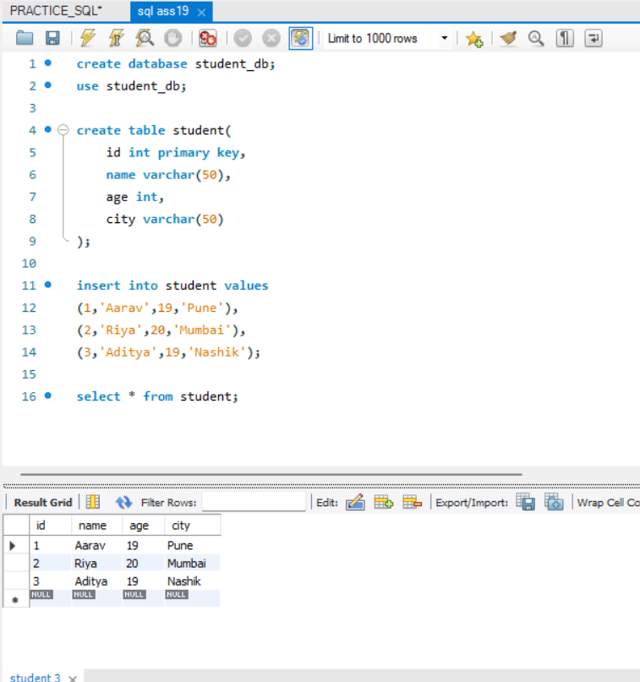

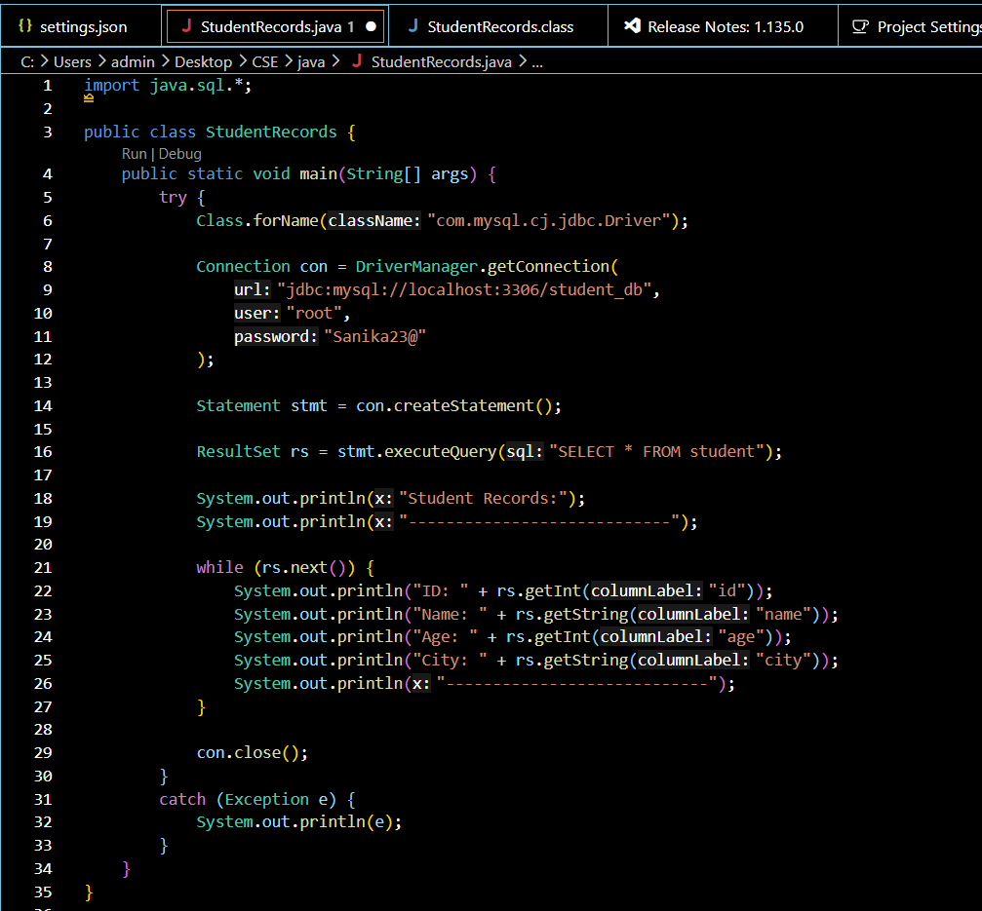

Output:
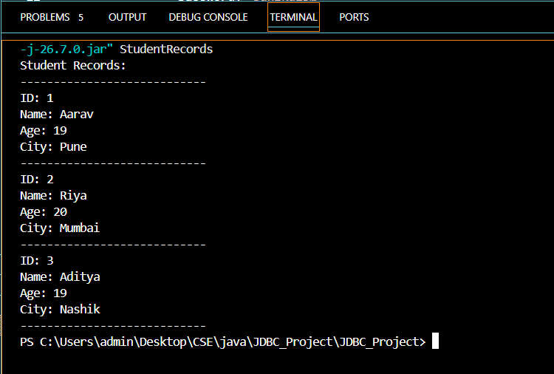

2. Create a Java application that connects to a database and displays product details using a SELECT query. Show product ID, product name, quantity, and price.
Code:
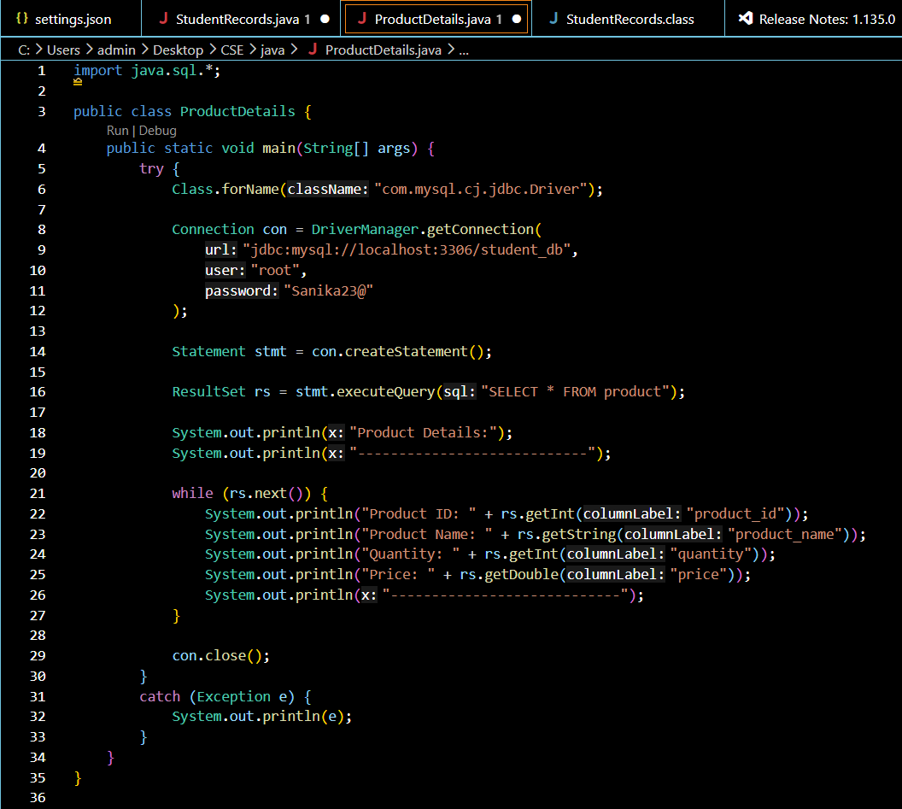
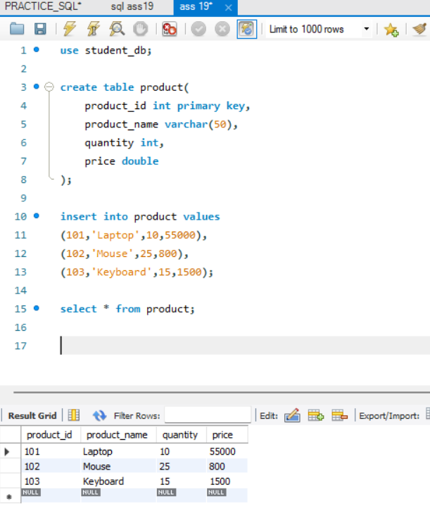

Output:
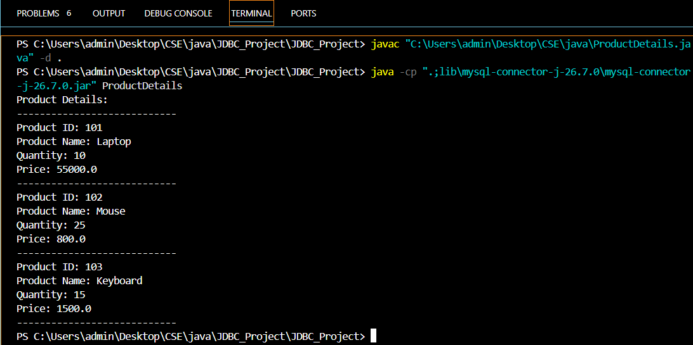

Conclusion
Thus, the Java application was successfully developed using JDBC connectivity to connect to the MySQL database and retrieve product details using a SELECT query. The program successfully displays the Product ID, Product Name, Quantity, and Price of the products stored in the database. This assignment demonstrates the practical use of JDBC for establishing a database connection, executing SQL queries, and retrieving records using ResultSet.

